 | TECHNICAL REPORT  NOTA TÉCNICA |  |  |  | No. Núm. | TE-T-NT-230046
 | Department  Departamento |  | Stress Methods & Optimisation |  | Aircraft Avión | Technologies
Title / Título
FastSizing v1.0 Tool Description
Keywords / Palabras clave |  |  |  |  |  | Access class  Clasificación acceso
FEM, Loads, Simulation  This information is of origin Airbus DS - Spain and is not export controlled |  |  |  |  |  | Airbus Amber P1
Revisions Record
Registro de Revisiones
 |  |  |  |  |  | Pag. 2
Summary / Resumen
The aim of this document is to provide an overview of the FastSizing Tool and to compile the most frequent known issues and solutions.
AIRBUS DEFENCE AND SPACE S.A.U. PROPERTY. This document shall neither be used nor completely or partially reproduced without previous written authorization of AIRBUS DEFENCE AND SPACE S.A.U. Military Aircraft Engineering Directorate.
PROPIEDAD DE AIRBUS DEFENCE AND SPACE S.A.U.. Este documento no puede ser utilizado ni reproducido total o parcialmente sin la previa autorización escrita de la Dirección de Ingeniería de Aviones Militares AIRBUS DEFENCE AND SPACE S.A.U.
Distribution /  Distribución |  | Execution /  Realización |  |  |  | Issue / Edición  Issue date / Fecha edición
A
17th February 2025
J. Weissbrich, G. Baños, P. Glez. Martín |  | Author  Autor |  | N. Calvo |  | Signature  Firma
J. L. Fauste, S. Iglesias |  |  |  |  |  | Electronic  signature
F. J. Gómez-Escalonilla
M. A. Calero, S. Ponce |  | Technical Approval Aprobación Técnica |  | E. Oslé
J. L. Melchor, M. M. Marzal
J. M. Glez. de la Calle
Authorisation
Autorización

REVISIONS RECORD / REGISTRO DE REVISIONES

Issue /  Revisión | Change reason /  Motivo de Modificación | Author /  Autor | Tech. Approval / Aprob. Técnica | Authorisation / Autorización
Date /  Fecha | Chapters, Sections, Sheets affected /  Capítulos, Secciones, Hojas afectadas | --- | --- | ---
17/02/2025 | First issue /  Primera edición | N. Calvo | E. Oslé

INDEX
1 INTRODUCTION 4
1.1 OBJECTIVE 4
1.2 ABBREVIATIONS AND SYMBOLS 4
1.3 REFERENCES 4
2 TOOL DESCRIPTION 6
2.1 REQUIREMENTS 6
2.2 INSTALLATION AND LAUNCHING 6
2.3 THE FASTSIZING WORKFLOW 7
2.4 FASTSIZING PROJECTS 10
2.5 HELP AND DEMOS 10
3 MATERIAL DB 11
4 KNOWN ISSUES AND SOLUTIONS 12
4.1 AUTOMATIC MATERIAL ASSIGNMENT FAILURE 12
4.2 ISSUES WITH REFERENCE SYSTEMS 12
4.3 SHIM PLIES 14
4.4 STRINGERS WITH NON-PERPENDICULAR WEB 14
4.5 ISSUES WITH MIDSURFACE GENERATION AND SUBSEQUENT MESH QUALITY 15

INTRODUCTION
The aim of this document is to provide an overview of the FastSizing tool and to compile the most frequent known issues and solutions.

The FastSizing tool is a customization embedded in the Hypermesh / Hyperworks environment developed for Airbus DS that provides a self-contained workflow for DFEM creation using CAD input as the starting point.

OBJECTIVE
The main objective of the FastSizing tool is to provide a workflow that accelerates the process of DFEM generation from CAD geometry.
The tool is built to take advantage of the standard Airbus DS CAD methodology to automate tasks such as material definition, property creation and assignment, reference systems definition, etc.

FastSizing also aggregates different HW existing features into a “left-to-right” set of menus that offer the user the opportunity of obtaining a solver-ready input file with minimal need to search for the necessary tool.

It also offers the benefits of standardizing the process, minimizing the chance for error.

However, some unexpected behaviours have been observed that could be solved in further development of the tool. Solutions for these issues are compiled in this document to provide the user with a way of continuing the workflow with minimal inconveniences.

ABBREVIATIONS AND SYMBOLS
Symbol Units Definition
A/C Aircraft
BC Boundary Condition
CAD Computer Assisted Design
DB Database
DFEM Detailed Finite Element Model
GUI Guided User Interface
HW HyperWorks
HM HyperMesh
LC Load Case

REFERENCES
Document Reference Issue Title
- [Altair] - FastSizing Version 2019.1.3.2 Documentation
- TEA-T-NT-190042 A Engineering Work Specification. Customization Of Altair HYPERWORKS. R&T project CERTERIN-FastSizing 2019.
- Amdt-I TEA-T-NT-190042 A AMENDMENT I TO TEA-T-NT-190042-A - CHPT. §3 DETAILS ON FE MODELLING RULES

TOOL DESCRIPTION

REQUIREMENTS
The necessary prerequisites to be able to fully use the FastSizing tool are:
- Operating System: Windows/Linux.
- HyperWorks 2019.1.1 or higher version.
- Hypermesh Desktop application must be used (not Hypermesh).
- For Document Report, Microsoft Excel and Word must be installed.
The geometrical input must be a CATIA V5 CATProduct.

INSTALLATION AND LAUNCHING
The FASTSIZING package contains an installation script named “INSTALL_windows.bat” that can be run and sets up a permanent pull-down menu in HyperMesh Desktop that when clicked on launches the FASTSIZING tool and shows the browser described in section 2 of this document.
- FastSizing pull-down menu
However, it has been observed that this installation script may not always properly function. In that case, the user is always able to launch FastSizing by running the script “FastSizing_GUI_Main.tbc” which can be found in the main FastSizing folder. To do so, in HM Desktop 2019.1 the user can follow the next steps: File > Run > Tcl/Tk Script. In HW 2021.2 or higher versions: File > Load > Script (*.tcl, *.tbc). This launches an “Open File” window. By default, only *.tcl files are shown. Change this filter to *.tbc to select the correct file.
Care must be taken not to modify the file structure presented below since there are interdependencies between the different files.
- FastSizing file structure

THE FASTSIZING WORKFLOW
Once FastSizing is made available inside the HW / HM environment, a new browser tab is opened next to others such as the Model Browser, Session Browser or the Mask Browser. This tab contains a set of menus that the user may use to generate the FEM.
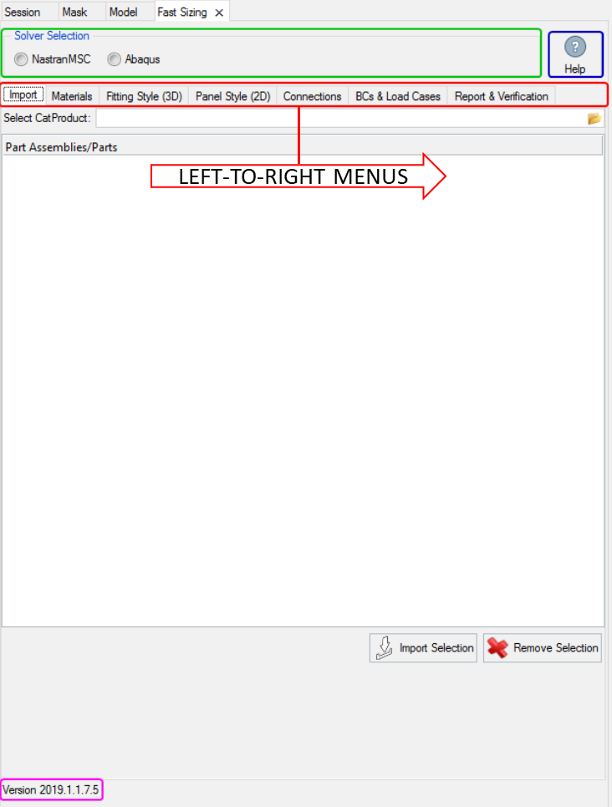
- FastSizing GUI
The FastSizing workflow allows the user to follow this set of tabs in a sequential order, from left to right. Each tab contains a group of tools that may be used from top to bottom. Figure 3 offers an overview of this workflow and the main actions that are performed in each tab.
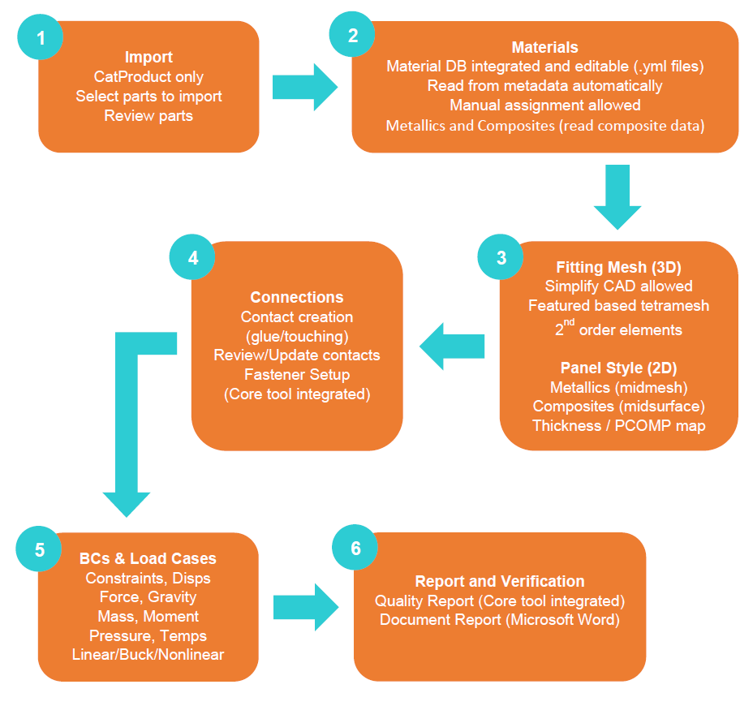
- FastSizing workflow
The main steps to follow are described below:
- Import:
  - Solver selection: Allows the user to select the solver to be used. This automatically changes the HW profile. At the moment only MSC Nastran and Abaqus are available.
  - CATProduct selection: This loads the complete CATProduct structure into the lower browser, organized by assemblies and CATParts.
  - Assemblies/Parts selection: This browser allows the user to refine which parts of the CATProduct will be kept for modelling and which ones will be removed
  - Import/Remove Selection: Action buttons that execute the previous options
- Materials:
This menu offers the user two features:
- Consult information about the materials available in a custom material database
- Material assignment to Parts/Plies: By default, this is made automatically based on CAD metadata matching material DB entries. If, for any reason, automatic assignment is not successful for one or more parts, or the user desires to modify it, manual assignment is also available.
- Meshing:
FastSizing has been developed with two different types of parts to be modelled: 3D parts such as fittings and thin reinforced panels typical of aerospace structures. Two separate menus are available and the user must select one or the other depending on the part at hand: Fitting Mesh (3D) and Panel Style (2D). Using different tools and algorithms, both of them offers the user these two steps:
- CAD Simplification: Prior to meshing the part, some features may be removed or modified in order to obtain a simpler geometry that leads to a cleaner, more regular mesh that achieves the best quality indices.
- Meshing step: This is the step where the mesh, materials and properties entities are created and assigned in the HM database. For 2D panel meshing two options are available depending on the material of the part (metallic / composite), which use “midmesh” technology for metallic and “midsurface” technology fir composites.
These steps may be re-done to improve mesh quality by further simplifying the geometry or changing the meshing options. This is especially relevant for meshing composite parts, where different extraction methods may be tried to achieve the best mesh possible. However, the user must be aware that repetition of these steps and/or use of other features external to FastSizing (which sometimes may be necessary) may lead to the tool failing to re-assign properties to elements. At any point in the process, the user can check the HW database via the Model Browser and correct any minor occurrences such as these.
- Connections:
This menu contains several tools to set up the interaction between different parts of the model defined in previous steps. The available interactions are:
- Contacts: Glued or Touching (the second only for non-linear analyses)
- Fastener Setup (1D): Create 1D fasteners using different methods such as Huth formula, Rutman, etc. Only available for MSC Nastran interface.
- BCs & Load Cases:
This menu offers the user the possibility of creating a complete set of load cases without needing to exit the FastSizing browser. The types of loads/BCs that are available are:
- Constraints
- Displacements
- Force
- Gravity
- Mass
- Moment
- Pressure
- Temperature
A useful feature integrated in this tool is the option of creating a load in “Single node (rigid/rbe3)” modes that will automatically create an element of said type to apply and distribute the load among a group of selected nodes.
For the load case creation step, only three solution types are available: linear static, linear buckling and nonlinear static. Only one of them can be applied at a time. Boundary conditions and loads created in the previous step will appear in tabular format with checkboxes to select them for each load case created, making it a very efficient way of defining LCs when these entities may be combined and reused.
Finally, an “export solution” is available to extract the input file for the solver selected in the beginning.

- Report & Verification Menu:
Prior to this last step the HM database file must be saved and the model may be run in the solver so that the reporting features may read these files.
An additional menu is available to aggregate the main features used to generate an automatic report with a predefined sections structure that provides an overview of the model definition and the results. This offers the user an advanced starting point to speed and standardize the documentation process.
For an in-depth description of each menu, please refer to Ref. 1.

FASTSIZING PROJECTS
The progress of the work performed using FastSizing may be saved in a HM database (*.hm).
To resume working with FastSizing after closing the HW program, follow these steps:
  - Open the .hm database
  - Launch FastSizing (from dropdown menu or by loading the GUI script)

HELP AND DEMOS
The main documentation file for FastSizing can be accessed directly from the GUI by clicking on the “Help” button within the “Import” tab (see blue square in Figure 2).
A presentation with the main key points is also available at:
\\efs\Infocalculo\calculo\FEM\DFEM\Fastsizing
Additionally, this folder contains:
- A modified “materialDB” that includes a “designations.yml” file with an added CADname for an existing material (as discussed in section 3)
- Both 2019.1.3.1 and 2019.1.3.2 versions of the FastSizing package
- Example CATProduct
- A video demonstration of how to use the tool with one example for each type of part (fitting style and panel style)
- A video demonstration of midsurface clean-up for a typical situation that the user may encounter (as discussed in section 4.5)
- A folder with a demo on how to create stringer laminate systems (see section 4.2.2) and the .tcl script to assign FastSizing metadata to such systems.

MATERIAL DB
An integral part of the design of the FastSizing tool is its material database where the information of different materials and standards is stored and the cross-referencing between CAD conventions and FEM is defined to allow for automatic recognition of metadata and creation of FEM entities.
The database consists of 5 files:
- cores.yml:
- designations.yml: file that establishes the association between CAD material names and materialDB material names
- fasteners.yml
- fibrous_composites.yml:
- metal_alloys.yml:
The material DB is stored in YAML format, a human-readable data serialization language that may be modified by the user to add new materials and standards, change material designations or modify values.
Designations follow the next structure:
CAD_name : [code , designation]

Where the “CAD_name” is the name that will be read from the CAD metadata; the “code” corresponds to the category of material it belongs to (“C” for composite materials, “M” for metallic alloys, “H” for cores and “F” for fasteners). An additional category is referred to by letter “N” for Non-structural materials which won’t be included in the FEM; and the “designation” which is the name that will be searched for in the corresponding materials file to the CAD name.
A simple example of how to modify this file is the addition of a new way of naming a material in the CAD input for an existing material in the DB:
- Example of how to modify the materialDB

Remark: if a required Material is not found in the database, please contact the Stress Methods and Optimization team for an update.

KNOWN ISSUES AND SOLUTIONS
The FastSizing tool has been developed based on a set of specifications and use-cases that may not cover all the possible situations in which such a tool could be useful. Therefore, intensive use of FastSizing may lead to encountering unforeseen behaviour which could draw back from the advantages of the workflow. Here below the user can find explanations to these issues, ways to work around them and continue the modelling process with minimal setbacks.

AUTOMATIC MATERIAL ASSIGNMENT FAILURE
Issue: Automatic material assignment to parts/plies may sometimes fail, resulting in empty cells for “Type” and “Designation” columns in the Materials tab of the FastSizing tool. This can be due to one of two reasons: either the corresponding material is not defined yet in the FastSizing material database, or the name used for it in the CAD Product is not included in the designations file. This can be solved by modifying the FastSizing materialDB files, but the user should proceed with caution if a new material must be introduced.
Workaround: If the problem lays in the designation matching process, please refer to section 3 or Ref. 1 for a detailed explanation on how the Material DB works. Sometimes, although the material of the part/ply already exists in the DB, and its name is already included in the designations file, some minor deviations with the CAD naming convention used to develop FastSizing may lead to errors. An example of this is a material name containing blank spaces. Depending on the version of FastSizing in use, even if the user adds the new name in the designations file, if it contains blank spaces the automatic assignment fails. Version 2019.1.3.2 of FastSizing should solve this problem and the user could define a designation with blank spaces embedded, but be aware of this issue with earlier versions.
If the material assignment failure is due to lack of existence of the material within the database, please contact the Stress Methods and Optimization team for an update.

ISSUES WITH REFERENCE SYSTEMS

Duplicate Import of Reference Systems
Issue: when importing some composite parts multiple instances of the same reference systems for the ply groups are created and stored in the model browser. This may lead to confusions on which system to apply.
Solution: It can be seen that only the original ones (the necessary ones) carry associated metadata from the FastSizing process. These are to be kept. The rest of the duplicate systems may be deleted with no influence on the rest of the process.

Reference System Import Failure
Issue: When trying to mesh (Panel Style 2D) a composite part, sometimes an error message appears, stating that no system is associated to the ply group.
Workaround: To fix this, go to Model Browser, right click on the corresponding plies and select the Card Edit option. Next to the “Ply System” field, click on the “Unspecified” button and this will open a selection menu. Select the correct reference system for each ply (it is possible to multiselect and apply a system to a group of plies) and click on “proceed”.

FastSizing Does Not Import Any Ply Reference System
Issue: In certain situations, the user may find that when importing a CAD Product that contains composite parts, one or more reference systems are missing. This will lead to an error when trying to mesh the part.
As it has been stated in previous sections, the FastSizing workflow is based on reading CAD metadata and creating FEM entities based on this information. This process relies on a set of conventions of how the CAD is built and what objects it contains. It has been found that CAD reference system definition for composite parts has changed since the standard used to develop FastSizing. In older releases of CATIA such as V5R21 ply orientation is defined in relation to a reference system directly input into the “Ply Group”. In later releases such as V5R27, a new “Rosette” object that contains the reference system, is input into the “Ply Group” to define ply orientation. This new entity is not recognised by FastSizing, leading to failure of importing the reference system.
Workaround: In these instances, the user will need to generate these systems within HM (or import them from CAD outside the FastSizing tool).
To do so, the user may follow these steps:
- Take two parallel lines that are perpendicular to the stringer web
- Create 3 nodes on each line (by using the “Extract On Line” option, inside the Nodes menu)
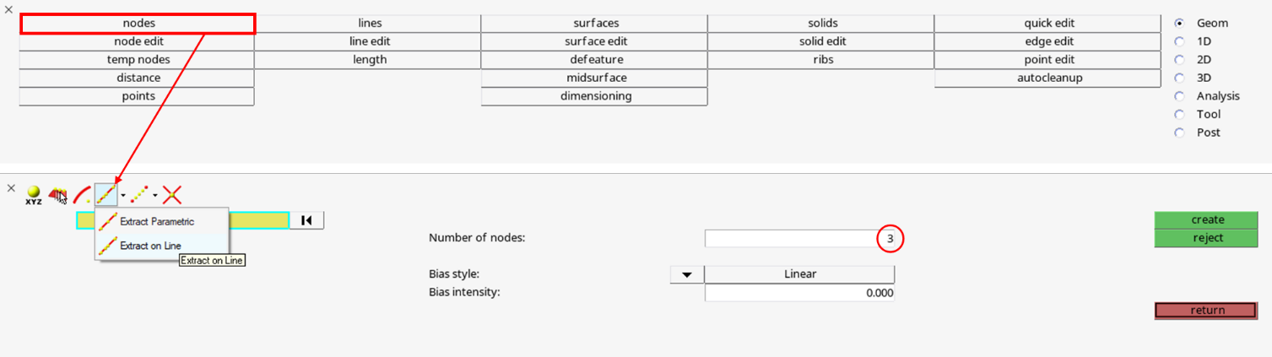
- Steps to create a node in the centre of a line
- Go to 1D/Systems and create one using the Origin, X axis and X-Z plane options. Make sure that the Z axis is perpendicular to the web and is pointing in the adequate direction.
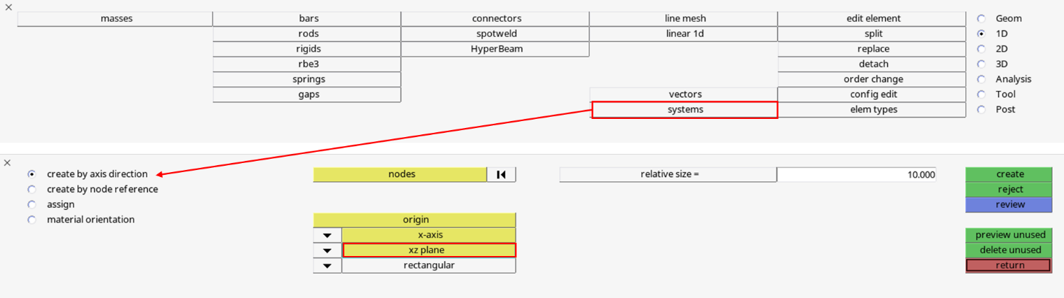
- Steps to create a reference system
Additionally, to continue with the FastSizing workflow, the user needs to assign these systems to the corresponding plies and associate the FastSizing metadata to these entities with a .tcl script provided by Altair.
- Assign the systems to the corresponding plies using the Card Edit menu
- Run the tcl script named “FastSizing_workaround_systems.tcl” (see section 2.5)
  - Select the PLY component (NOT the SPC component)
  - Select the systems

2D Element Orientation
Issue: It has been observed that, by default, FastSizing defines element orientation for Panel Style (2D) by means of the THETA angle (field 8 for CQUAD4 elements, and field 7 for CTRIA3 elements) instead of using the MCID option. This is not the standard approach.
Workaround: It is advised to always review element orientation and align each components elements with the corresponding reference system before exporting the model.

SHIM PLIES
Issue: When importing a composite reinforced panel, the user may observe groups of plies that feature a ply shape with a circular pattern around the centre of the longitudinal axis at both ends of a stringer. These ply shapes define only circles, not surfaces, and therefore do not follow the expected definition of a ply in the FastSizing specification. These plies represent the shim of the stringer and the user may choose to model it or not depending on the assumptions for that particular model.
Workaround: If the user chooses to model the component without the shim, they can remove these plies from the model, but it is important to do that after material assignment is completed in order to avoid repeated warning messages about missing material assignment (these plies entities will continue to exist within the FastSizing materials menu, and eliminating them before material assignment will cause these error messages).
Additionally, be aware that the STACK entity created for a laminate contains metadata with the ply list it belongs to. The user should modify this metadata (right click on card edit and delete the corresponding ply numbers) before continuing with the FastSizing process.

STRINGERS WITH NON-PERPENDICULAR WEB
Issue: In the assumptions used to define FastSizing specifications, a typical reinforced panel was considered to always have stringer webs perpendicular to the panel itself. However, some applications with curved panels and stringers with oblique webs are not uncommon in aerospace structures. When applying the FastSizing workflow to these components, the user may find that mesh quality can be poor in some areas of the stringer where the projection of the web’s outline on the flanges is used as a partition of the surface to guide the mesh.
Workaround: It is possible to edit the midsurface and toggle these edges so that the mesh does not follow them. HM will then automatically re-mesh the edited surface, but the properties will not be automatically reassigned. It will be necessary to manually assign them to the corresponding elements.

ISSUES WITH MIDSURFACE GENERATION AND SUBSEQUENT MESH QUALITY
The FastSizing tool workflow for composite parts is designed to first use the HW Midsurface tool to extract a simplified 2D version of the part and then use the automatic mesher to mesh the surface generated. The midsurface needs to have a proper topology to allow the mesher to proceed. But even if the topology is ok to perform the meshing process, it is also important that the surface is simple enough in order not to introduce unnecessary details that will lead to poor element quality.
There are 5 different midsurface extraction methods. The user may try out different methods to find the most adequate one for each part.
In certain situations, none of the different midsurface extraction methods provide good enough results by themselves. The extracted geometry may have a high complexity or even some areas with inadequate topology. In these instances, clean-up of the midsurface becomes necessary.
As it was mentioned in section 2, the FastSizing tool already contains some geometry clean-up tools within itself, such as the “Quick Edit” panel, that provide the user with the most frequently used features to perform this task. However, other HW tools may be needed in some occasions.
Issue: It has been observed that meshing of stringers may show these issues quite often. The next steps usually provide a satisfactory mesh for a typical stringer:
- Try different extraction methods to obtain the best possible starting point
- Partition the extracted midsurface into three separate surfaces following the next pattern, and delete the centre resulting surfaces of the stringer (web depicted in red, flanges in blue for visualization purposes), using the quick edit tools “Split surf-node” and “Delete surf”:

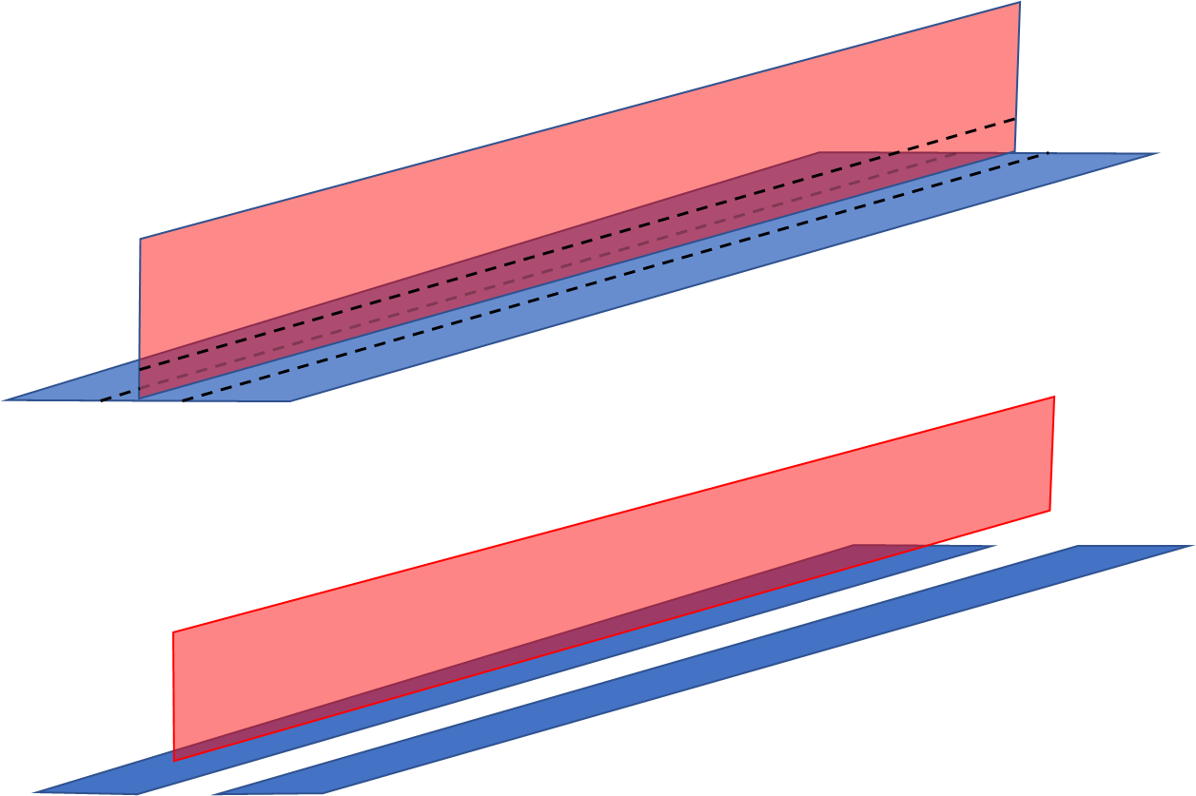
- Partition of typical stringer midsurface for geometry clean-up

- Extend the remaining surfaces to regenerate the central area of the stringer, using the “Surface Edit” menu with the option “Extend” (choose an appropriate gap). Repeat this step if necessary.
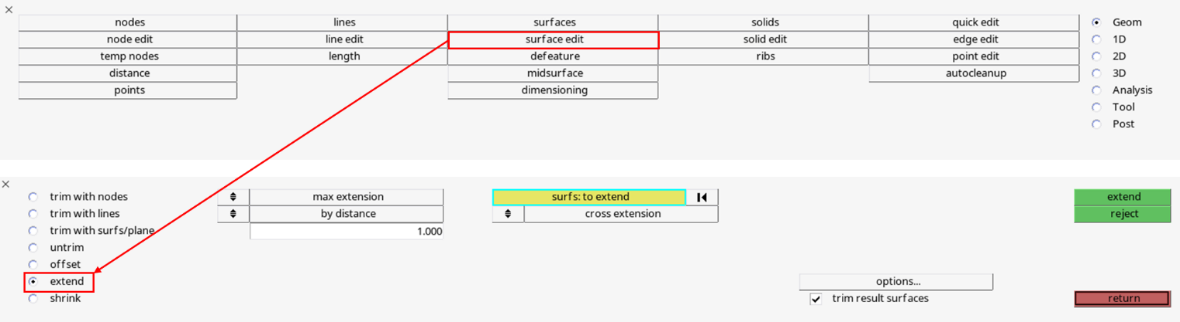
- Extend Surfaces tool.
- Further clean-up may be necessary. Some other frequently used tools are: “toggle edges”, “replace points” etc.

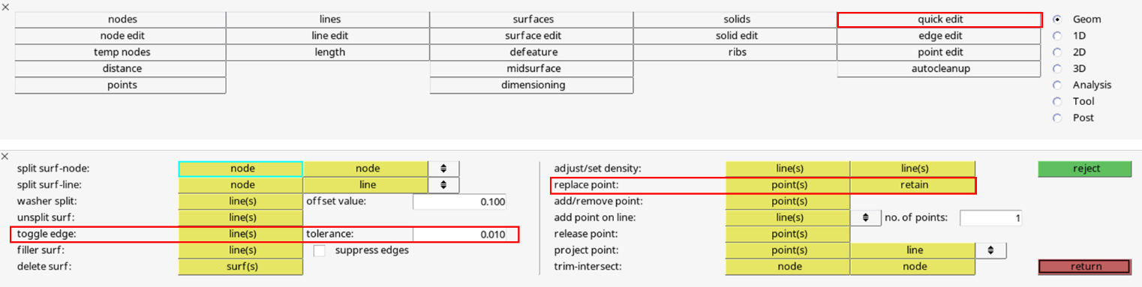
- Quick Edit Panel.
In HyperWorks version 2021, the user may access all these tools using the search bar and introducing the name of the desired tool. However, some of these tools may be deprecated in later versions (i.e. HyperWorks 2022 & 2023). Other similar tools may be available within the geometry ribbon.
In some cases, the initial midsurface may be too complex and the previous process may not be enough to obtain acceptable results. It may then be a good option to simplify the solid geometry before extracting the midsurface. For instance, surface fillets around the centre of the stringer’s cross section may cause the midsurface tool to give more complex results. If these fillets are eliminated, the initial midsurface that HW generates may be much better and easier to clean up. To do so:
- Go to Geom → Defeature → surf fillets
- Use the first method to find the whole fillet at once and remove it
After extracting the midsurface, it may be necessary to perform the previously described process.
Other tips for situations such as this:
- It may be possible to obtain better results with a midmesh directly on the stringer, although this will not align well with the FastSizing workflow. This way, composite information like laminates and orientations may not be properly assigned to the corresponding elements.
- When replacing points (Quick Edit menu) that are separated by a big enough gap, it is recommended to use the “Geom Match Topology” (under the “Geometry” drop-down menu for Hypermesh Desktop 2019.1.1, or under the Cleanup menu of the Geometry ribbon for later versions) on these surfaces.
- If a certain area contains defects that are not easy to clean up, an option would be to split (split surf-node) the surface to isolate that area, delete it (delete surf) and then fill the gap with a ruled surface
It is expected that intensive use of the tool will result in more unexpected circumstances that will require new workarounds or solutions, but this will be in favour of both the tool and the users. For further support with FastSizing, please refer to the Stress Methods team.

